Northern Gateway Housing and Employment Allocations (Bury) – Greenbelt removal – OBJECTION V1 (objections to all portions of this allocation NG1a, NG1b, NG1c)
David P Bentley Ecological Consultant www.davebentleyecology.co.uk
Representing – nature conservation and landscape
The open land between Bury, Whitefield, Prestwich, Heywood, and Middleton to be destroyed – 5200 houses and employment floorspace
1 The wrongly assessed Housing and Employment Need
1.1 The well-loved countryside wets of Whitefield and Prestwich, and several other parts of the borough, is about to be destroyed on the whim of the local Labour Party. They claim it is the government’s fault. That is not true. Labour controlled Local Authorities hired the population forecasters. Labour chose the Accelerated growth option when they could have chosen a lower growth option. Labour decided to ignore the benefits of reduced migration that we will get from leaving the EU. Labour has 90% of the seats on the Greater Manchester Combined Authority and control Bury Council. This hated plan is Labour’s work. It is a political project divorced from actual housing and employment needs.
“Option 1 GMFM Baseline 2014: The standard baseline forecasts produced as part of the annual GMFM release in 2014 which draws on OE’s national and regional forecasts. This provides a level of growth and development consistent with GM’s existing land supply, as identified by the ten local authorities. The baseline is therefore a ‘policy neutral’ forecast.
Option 2 AGS-SNPP 2014: An Accelerated Growth Scenario providing a projection for the GM economy that is stronger than the baseline forecast, and reflects a future where the city plays a lead role in the development of a ‘Northern Powerhouse’. It also meets GM’s aspiration to provide additional employment opportunities to non- employed local residents. The scenario adopts demographic assumptions set out in 2012 sub-national population projections (SNPP).”
1.2 The Labour Party chose Option 2. A political decision. In doing so they ALSO chose to ignore the end to the environmentally damaging effects of mass migration that will occur with Brexit. This is specifically cited in the background papers to the GMCA/AGMA Executive Meeting of August 2016.
1.3 This is what the recent past tells us about Bury’s population increase since 1981. I did not need to pay population forecasters tens of thousands of pounds. I just checked the census totals for the Borough from 1981 to 2011. Here’s what they say and my conclusion.

Bury Pop 1981 175 459. No figs before then as no Bury MBC in 1971.
Bury Pop 1991 179 168. 371 rise in 10 years, 371 in a year average.
Bury Pop 2001 180 608. 1440 rise in 10 years, 144 in a year average.
Bury Pop 2011 185 060. 4452 rise in 10 years, 445 in a year average.

We can maybe put the recent rise down to immigration from the EU, given the rise of numbers of say Polish speakers in the Borough. This will cease on Brexit.
So the worst case scenario is that with a 445 person rise a year for next 20 years 8900 new people will live in Bury. That is assuming Free Movement will continue, which it will not. Assume 2.2 people per home – 4045 homes. I just checked my half of my street – it is 2.3 people per home.
So remain a member of the EU build 4045 homes. Drop to before the Eastern European nations were granted freedom of movement and it is 2880 new people in 20 years. At 2.2 people per home it is 1309 homes. THE GMSF FORECAST OF 12,500 HOUSES IS BEYOND RATIONALITY.
1.4 Something we learned from the EU Referendum and aftermath is that a whole host of economic forecasters were totally wrong – doom was forecast from the moment the UK voted to leave. My opinion is that the Oxford Economics forecast as originally made for new homes, considering the above, is worthless.
1.5 The Greater Manchester Strategic Housing Market Assessment Oct 2016 reports Bury MBC has existing supply of land for 4786 houses and a potential windfall of 1000 houses up to 2035. This is more than the requirement should we remain a member of the EU, and many times more than would be required on leaving.
1.6 Now Bury has been allocated 12,500 houses. The sums of the Greenbelt deletion housing allocations are W 1250, B 60, S 135, H 100, E 3460, N 200 + 1000 + 3400 + 600 = 10,205. Given AGMA and Bury MBC considered it had non Greenbelt sites for 4786 plus 1000 windfall (making 5786) then, with these Greenbelt deletions, Bury will actually have space for 15,991 houses - which is ludicrously over any imagined ludicrous target. Clearly the GMSF has allocated fantasy allocations to Bury. The officers responsible should be dismissed. If this was some planner making a rational decision my comment might be out of order. It is not. This is a case of true incompetence which has caused massive financial cost and widespread emotional upset.
1.7 The buffer the GMCA have applied to elevate Bury’s housing target is also unnecessary. Given that the GMSF target is so massively an over calculation there is no need to apply a buffer to allow for flexibility. The likelihood is that people will leave Bury if these plans are approved.
1.8 The figures the GMCA use are based on an expectation of approximately 1.3 persons per dwelling. The 2011 census had a UK average of 2.3 persons per dwelling compared to 2.4 persons per dwelling in 2001. This therefore seems to assume that a lot more people will be living alone and households are getting significantly smaller, far more than the rate in the previous decade for which data is available.
1.9 GMSF Strategic Options Background Paper 3. Objectively Assessed Housing Need has one brief mention of empty houses in a 200 page report, whilst the GMSF document has zero mentions in 240 pages.
1.10 The mishmash of housing and urban edge the GMSF will create for decades as development proceeds on a slow scale will degrade the town’s landscape. It will blur the urban rural edge and lead to chaotic planning, and wholesale wildlife destruction as well.
2 Lack of consultation
2.1 The lack of consultation has been breath-taking. The process is contrary to Bury Council’s own guidelines – its Statement of Community Involvement - thus:
“How will the Council involve you?
“The following table lists some of the activities and methods the Council will consider using when undertaking consultation exercises in connection with the Local Plan. The methods used will be tailored to suit the scale and nature of impact of the decisions to be made and the particular needs of people being consulted:” THIS IS THE BIGGEST DEVELOPMENT PLAN THE COUNTY HAS KNOWN.
“Material made available on the Council’s web site, in Council offices at Knowsley Place Reception, Town Hall Reception and selected local libraries (see our Statement of Community Involvement web page on http://www.bury.gov/10738 for a list).” The ALLOCATIONS MAPS AND TEXT ARE NOT AVAILABLE ON THE COUNCIL WEBSITE. THERE ARE NO DISPLAYS, POSTERS OR LEAFLETS IN ANY COUNCIL RECEPTION IN THE BOROUGH; THE COUNCIL OFFICE IN KNOWSLEY PLACE HAS NOTHING, AND DIRECTS CALLERS TO A 15 MINUTE QUEUE AT THE TOWN HALL. AT THE TIME OF THE UDP THERE WERE PERMANENT DISPLAYS IN 3 TOWN CENTRE LOCATIONS.
“Send letters and emails to database contacts, including targeted consultation letters for key community groups. The Council may consider more targeted consultation where residents may be more directly affected by proposals.” NOT DONE (NOT TO ME!)
“Advertise via social media on Facebook & Twitter.” NOT DONE. I’M HEAVILY INVOLVED ON FACEBOOK AND HAVE SEEN NOTHING FROM BURY OR GMCA ON THIS MATTER.
“Where possible, place articles in:”
“Local newspapers;”
“‘Planzine’ - the department’s e-newsletter sent to a database of contacts and”
“Using other online news sources as appropriate.”
“Use posters on notice boards in prominent locations including town centres, civic suites, markets, leisure centres and public open spaces.” NOT DONE. EVERYWHERE HAS BEEN CHECKED. THE COUNCIL HAS DONE NOTHING IN THIS REGARD. THE BURY LIBRARIAN WAS ASKED WHERE THE POSTER WAS ON GMSF. HE SAID THERE WAS NONE, BUT THAT THE GMSF STUFF WAS IN A BOX BEHIND HIM.
2.2 This consultation is contrary to Bury Council's Statement of Community Involvement, and is clearly UNLAWFUL. http://www.bury.gov.uk/index.aspx?articleid=10738. Furthermore at least one officer at Bury MBC has intentionally lied by writing to an official complainer stating that the council is in full compliance with the Statement. I expect that officer to be dismissed.
3 Allocating a Site of Biological Importance to Employment land is illegal, gross negligence on the part of Bury Planners.
3.1 This is not just a deletion from the Greenbelt. It is placing a Site of Biological Importance (Pilsworth Reservoirs), which LPAs are required to protect in the planning process by numerous Central Government instructions, into a housing allocation. It is illegal. The officers responsible for proposing this should be dismissed. The National Planning Policy Framework states (Para 110) “In preparing plans to meet development needs, the aim should be to minimise pollution and other adverse effects on the local and natural environment. Plans should allocate land with the least environmental or amenity value”…..IT DOES NOT STATE PLANS SHOULD ALLOCATE TO HOUSING LAND WITH SITE OF BIOLOGICAL IMPORTANT STATUS, or indeed SPECIAL LANDSCAPE VALUE STATUS. The Walshaw Allocation is illegal. The NPPF also states (para 116) “Planning permission should be refused for major developments in these designated areas except in exceptional circumstances and where it can be demonstrated they are in the public interest…..” There is no exceptional need for this housing, certainly not “accelerated growth” and whilst in the Greenbelt the SBI is safe BUT the housing allocation/greenbelt deletion will certainly lead to the destruction of the SBI to make it developable. We have seen that happen to Bury’s SBI’s on several occasions – Edgar’s Field (most recently), Spen Moor, Pilsworth Bleach Works, Chapelfield Lodges and Townside Fields and on Features of Ecological Value at Openshaw Fold. Currently there is a concern that the employment allocation will lead to the draining of the reservoirs, landfill to create a flat site, and the building of units once the wildlife has been destroyed. The owner has been approached to consent to access the site for drawing up a planning application for an unknown scheme and the worst is feared.
4 Religious offence and widespread outrage
4.1 In doing what they have done the officers responsible have caused in me harm and offence to my religious sensibilities, and across the borough they have caused widespread distress and outrage. Bury has never before placed a Site of Biological Importance within a housing allocation and, with good fortune, the officers who did this will be dismissed and expelled from the profession. It is an offence to my religion to put wildlife and landscape in peril like this, and, as a religious outrage, the allocation should be withdrawn, and the responsible people removed from office. I have just as much right to make these claims as anyone else, from any religion.
5 Greenbelt Status
5.1 The Northern Gateway allocation land has been assessed on behalf of AGMA as strong on all counts in terms of functionality as Greenbelt –
5.2 Pole Lane & Hillock Area “The parcel is adjacent to Whitefield. There are limited urbanising features within the parcel; development consists of playing fields and buildings associated with Close Park to the north-east. There is a strong sense of openness with the parcel because of a land use of recreational sports fields, woodland and rough ground. The parcel plays a strong role in checking the unrestricted sprawl of Whitefield.” And “The parcel is adjacent to Whitefield. The parcel has significant and durable barrier features including the M66 motorway to the east and the M62 motorway to the south that play a strong role in inhibiting urban sprawl occurring within the parcel. The parcel plays a strong role in inhibiting ribbon development along Pole Lane and Hills Lane. The M60 provides a barrier to the onward spread of sprawl beyond the parcel boundary to the east.”
5.3 Of the Baguley Brow area the assessment says “There is limited/no sense of encroachment with the parcel being generally free of urbanised built development. The landscape within this parcel remains largely unspoilt by urbanising influences located outside its boundaries. It has an intact and rural in character and displays characteristics of the countryside.”
5.4 Of the area including Simister, Pilsworth, and Whittle Brook the assessment says “The parcel lies between the settlements of Heywood to the north, Middleton and Rhodes to the south-east and Whitefield and Prestwich to the south-west. The parcel plays an essential role in preventing the merging or erosion of the visual and physical gap between these settlements in particular forming a significant portion of the gap between Heywood and Middleton and Heywood and Whitefield which are located within approximately 1.3km and 1.7km of each other.” An essential role that Labour has decided to turn into housing and employment land.
5.5 The Greater Manchester Structure Plan was adopted after approval by the Secretary of State in March 19819, and was later reviewed and superseded by a later version in 1986. The main themes of the 1981 Structure Plan were: 1 Urban concentration; 2 Redirection of development to the inner core; 3 Maintenance of the regional centre (linked to the regeneration of the inner areas of Manchester and Salford); 4 Resource and amenity conservation. These themes are still vital today and seem equally vital to the Northern Powerhouse ideals. You cannot grow and make strong and beautiful what you are seeking to destroy and squander and neglect. The GM green belt was designed to complement these efforts to regenerate existing urban areas.
5.6 The National Planning Policy Framework (NFFP) states (Para 79) “The Government attaches great importance to Green Belts. The fundamental aim of Green Belt policy is to prevent urban sprawl by keeping land permanently open; the essential characteristics of Green Belts are their openness and their permanence.” It goes on to state (Para 83) “Once established, Green Belt boundaries should only be altered in exceptional circumstances, through the preparation or review of the Local Plan. At that time, authorities should consider the Green Belt boundaries having regard to their intended permanence in the long term, so that they should be capable of enduring beyond the plan period.”
5.7 The UDP revised the Greenbelt boundaries at the time of the UDP (c1995). There were minor adjustments, additions and deletions, and the creation of a new strategic employment site at Bury Ground, which was removed from the Greenbelt. Bury Ground is still mostly empty 22 years later, with only the relocated Fire Station and police Station which their original bases are rotting in the town centre, standing derelict eyesores. This is what strategic removals from the greenbelt did to our town. Stole a country park and added dereliction. So are Bury planners fit to make such decisions like this again? I think not.
5.8 There are no exceptional circumstances here. Bury MBC can meet its actual housing requirements using existing land supply without affecting the Greenbelt. The GMSF Policy on Greenbelt states the ‘Green Belt will be afforded strong protection in accordance with the National Planning Policy Framework.’ The only thing exceptional about this is the stupidity and indeed incompetence of those involved in the preparation of the framework, and the exceptional nature of the breach of the Bury MBC’s Statement of Public Consultation.
5.9 Fundamentally the Greenbelt grabs in Bury are totally contrary to this main theme of Greenbelt – NPPF Para 80 “To assist in urban regeneration, by encouraging the recycling of derelict and other urban land.” We have seen that they would allow Bury to over supply housing without remediating and reusing any derelict land. We know from the Bury Ground experience (above) that it would encourage dereliction.
6 The importance of the allocation’s Landscape Character
6.1 In terms of Landscape Character Areas as defined by Bury’s abandoned Local Plan most of the Northern Gateway is classed as Fringe Settle Valley Pasture, with the Pilsworth Fisheries Valley as Fringe Industrial Brook. Special note should be given to the Whittle Brook as it is a rare Greater Manchester example of a living lowland brook through open fields that has oxbows. It is not constrained by walls, or weirs other forms of control. As such it may just be worthy of Site of Special Scientific Interest designation on geomorphological grounds. This untouched stream with its numerous feeder streams is set in a pondscape that is rich in Great Crested Newts.
6.2 Allowing people to appreciate the distinctive Northern Gateway area, the site is crossed with Public Rights of Way and tracks. The allocation has at least 3 angling clubs with their own self-managed angling reservoirs and ponds, a Cricket Club, a Golf Club, informal recreation at Boz Park with its own wildlife areahorse riding circuits and stables, and Simister has two village pubs, and there is the country pub at Three Arrows.
6.3 The farmed landscape supports Milk Cattle, Horses and poultry. Stretching from Pilsworth Reservoir to Baguley Brow this is Bury’s best agricultural land (Grade 3s), and only a few other fields of these grades are present in the Borough at Ringley. The allocation will destroy all this agricultural land.
6.4 In recognition of the open, undulating countryside here the UDP included all the open area north west of the motorway intersection as Special Landscape Area to be protected by policy EN9/1. The allocation mocks the planners who considered this a landscape of value.
7 The importance of the allocation’s Recreational value
7.1 Allowing people to appreciate the distinctive Northern Gateway area, the site is crossed with Public Rights of Way and tracks. The allocation has at least 3 angling clubs with their own self-managed angling reservoirs and ponds, a Cricket Club, a Golf Club, informal recreation at Boz Park with its own wildlife area, horse riding circuits and stables, and Simister has two village pubs, and there is the country pub at Three Arrows. Pilsworth Reservoirs in particular, in the last few years, invested so much in making the banking safe and attaining planning permission for a warden’s base to allow the business to grow.
8 The importance of the River Valley and Green Infrastructure
8.1 The UDP allocated the Pilsworth Reservoirs valley and the Whittle Brook corridor area to Protected River Valleys (OL5/2). “The Council is keen to retain the open character of the river valleys by controlling development”…altered from an earlier draft which read “….by ensuring that there is a general presumption against most forms of development. The current allocation is contrary to this protection. It places two Protected Rivers Valleys into employment allocation.
8.2 Green Infrastructure encompasses recreational spaces and areas of ecological value and these have a considerable role to play in promoting healthier lifestyles, adapting to the challenges posed by climate change, maintaining food production, protecting wildlife and attracting investment to an area. The emphasis nationally is therefore to maintain, improve and add to this resource by encouraging greater access and connectivity to deliver the above benefits across key areas in a strategic manner. Following a commitment in the 2011 Natural Environment White Paper, in October 2011 the Government launched a Green Infrastructure Partnership to facilitate the provision of local GI. Policy EM3 of the former North West Regional Strategy (2008) required local authorities to work together and with partners to conserve, create and enhance its green infrastructure. Later in 2008, AGMA commissioned TEP Consultants to assist in developing a green infrastructure framework for Greater Manchester. TEP were subsequently engaged to identify a more local network in Bury. The Greater Manchester GI Framework identified the whole area of Northern Gateway allocation west of the M66 from Unsworth to Heaton Park as Green Infrastructure Assets. A different approach was taken in “Bury’s Green Infrastructure Network.” It included the Roch Valley along with the Pilsworth Quarry, Pilsworth Reservoirs and Whittle Brook area as part of Roch Valley GI Action Area.
8.3 The objectives cited in Bury for the Roch Valley GI AA are:
Safeguard and enhance existing assets in the network;
Safeguard and enhance the growth support functions that the network provides;
Ensure new development as a minimum maintains environmental quality and functionality of, and increases access to, the network;
Improve functionality of the network, specifically using the existing assets to increase the resilience of the Borough to the effects of climate change;
Address sources of pollution or blight which degrade the quality or perception of assets in the network;

Create new or enhanced assets where there is an existing deficit of access, environmental quality or functionality;

Partnership working to deliver major projects within the Borough and across boundaries.

8.4 There is a mismatch between doing all of these lovely things to enhance Green Infrastructure, and building employment units all over the area, destroying and damaging many of the assets in the process.
9 The importance of the Habitat Mosaic
9.1 The open space around in Northern Gateway allocation contains one large council-designated Site of Biological Importance, as well as Whittle Brook and numerous small ponds. Present are large open waterbodies, small ponds formed in marlpits, and inundation areas, lowland streams - with cut off sections, a stream and riverside habitats, marshland, reedbed, berry-rich hedgerows, shrubland, mature woodland arms off Whittle Brook, hedgerow trees, working farmland of improved dairy grazing land, and semi-improved grassland alongside Whittle Brook (including acidic grassland) and on the west side of the “nursery” on Mode Hill Lane, old farmsteads supporting bats and owls and Swallows and House Martins.
9.2 The following UKBAP Priority Habitats are present in the mosaic – Eutrophic Standing Water; Rivers and Streams; Ponds; Wet Woodland; Hedgerows; Lowland Meadows; Floodplain Grazing Marsh; Reed Beds; Lowland Fen.
9.3 Here is what the National Planning Policy Framework states (para 117): “To minimise impacts on biodiversity and geodiversity, planning policies should:
● plan for biodiversity at a landscape-scale across local authority boundaries;
● identify and map components of the local ecological networks, including the hierarchy of international, national and locally designated sites of importance for biodiversity, wildlife corridors and stepping stones that connect them and areas identified by local partnerships for habitat restoration or creation;
● promote the preservation, restoration and re-creation of priority habitats, ecological networks and the protection and recovery of priority species populations, linked to national and local targets, and identify suitable indicators for monitoring biodiversity in the plan.”
9.4 It is ironic that in this area where three local authorities meet and once the Greater Manchester Council almost got around to making a River Irk Local Plan and River Roch Local Plan the only comprehensive cross-border planning is how to comprehensively destroy the landscape.
10 The importance of Mammals in the Northern Gateway Allocation Area
10.1 The area supports a wealth of mammals including Roe Deer, Rabbit, Badger, Red Fox, Brown Rat, Short-tailed Field Vole, Wood Mouse, Grey Squirrel, Hedgehog, Common Shrew, Mole, and Otter, which is known from the adjacent River Roch in recent years (others and I have recorded it). Seven species of bats have been recorded.
10.2 The site supports Hedgehogs – which is listed by the UK Government as a United Kingdom Biodiversity Action Plan Priority Species, given a 20% decline recorded over 4 years prior to listing as a UKBAP species. Concerns cited are traffic density, fragmentation of habitats, need for hibernation sites, need for hedgerows and wide field margins.
10.3 The site has been shown to support Badgers. Occupied Badger setts have a measure of legal protection. The cloughs alongside Whittle Brook may contain suitable sett habitat, as indeed might Pilsworth Quarry.
10.4 Four protected Bat species have been recorded in the affected area. The South Lancashire Bat Group, in two 1.5km radius circles around Pilsworth Reservoir and Simister Village, have recorded in recent times UK and European Law protected bat species Daubentons, Common Pipistrelle, Soprano Pipistrelle and Noctule The Noctule and the Soprano Pipistrelle are UK Biodiversity Action Plan Priority Species, i.e. “Species of principal importance for the purpose of conserving biodiversity” covered under section 41 (England) of the NERC Act (2006) and thus they need to be “taken into consideration by a public body when performing any of its functions with a view to conserving biodiversity.” For Noctules, which had a 21% decline over 6 years prior to UKBAP listing, the JNCC website shows a requirement to protect mature trees, wetlands, stream sides and other insect rich areas and boosting water quality – developing by streams and in the reservoirs and canal catchments of the allocation site will not help water quality. For Soprano Pipistrelles, which had a 42% decline prior to UKBAP listing, the JNCC website requires that the needs of the Soprano Pipistrelle are considered in agri-environment, planning, water quality, wetland creation …..policies The JNCC urges the creation, expansion and improvement of key habitats including wetland and features such as hedgerows and woodland edges. “Ensure adequate consideration of a landscape approach to the conservation of Soprano Pipistrelle.” Alas the housing and employment allocations do quite the opposite - a landscape approach to the destruction of wildlife habitat and wildlife corridors.
11 The importance of Birds in the Northern Gateway Allocation.
Birds have not been well-studied in this area. For instance there appear to be no records on Manchester Birding. Thus I need to rely on the time I have spent in this area – surveying ponds in the west of Whitefield in 1994, surveying all ponds in the Borough in 2005/6 and sundry consultancy jobs at Pilsworth Fisheries, Egypt Lane, and Brick House Farm. Only species of particular interest noted here:

11.1 Table of Bird Species recorded by contributors in the NG Allocation Area

UK/EU Law S41 Bern Migratory Spp BoCC4 English Name + notes)
UKBPS CMS2 AEAW2 RED (Northern) Lapwing
UKBPS BC2 AMBER Reed Bunting
Sedge Warbler
UKBPS RED Skylark
CMS2 AEAW2 AMBER Snipe

The latest record of Snipe was Jan 2017 on the stream north of Baguley Brow.

Codes to protected/conservation status:

UKBPS UK BAP priority species were those that were identified as being the most threatened and requiring conservation action under the UK Biodiversity Action Plan (UK BAP) – Now termed Section 41 species.
BC2 Bird recommended for protection as a result of the Bern Convention Appendix 2 to which the UK is a signatory. Special protection (`appropriate and necessary legislative and administrative measures`) for the animal taxa listed, including all forms of deliberate capture and keeping and deliberate killing; the deliberate damage to or destruction of breeding or resting sites; the deliberate disturbance of wild fauna, particularly during the period of breeding, rearing and hibernation, insofar as disturbance would be significant in relation to the objectives of this Convention.
CMS2 Convention on Migratory Species Appendix 2, to which the UK is a signatory. Migratory species having an unfavourable conservation status for which Range States are encouraged to conclude international agreements for their benefit.
AEAW2 Convention on Migratory Species, African-Eurasian Waterbirds Agreement - Annex II, to which the UK is a signatory. Conservation of migratory waterbirds, giving special attention to endangered species as well as to those with an unfavourable conservation status.
RED Status given by Birds of Conservation Concern 4. Uses several criteria - IUCN: Global conservation status. Species that are Globally Threatened (Critically Endangered, Endangered and Vulnerable, but not Near Threatened) under IUCN guidelines, as assessed by BirdLife International,
the IUCN Red List Authority for birds, in2015; Historical decline in breeding populations. Species judged to have declined severely between 1800 and 1995, from an assessment conducted by Gibbons et al. (1996a), and which have not recovered subsequently; Breeding population decline. Severe decline in the UK breeding population size (>50%) over 25 years or the longer term; Non-breeding population decline. Severe decline in the UK non-breeding population size (>50%) over 25 years or the longer-term; Breeding range decline. Severe decline in UK range (>50%) between the breeding bird atlases in 1988–91 and 2007–11 or 1968–71 and 2007–11 , as measured by the calculated change in the number of occupied 10-km squares; Non-breeding range decline. Severe
decline in UK range (>50%) between the wintering bird atlases in 1981–84 and 2007–11, as measured by the calculated change in the number of occupied 10-km squares.
AMBER Status given by Birds of Conservation Concern 4. Uses several criteria - European Red List status; Historical decline – recovery. As described above, previously Red-listed for historical decline, followed by an increase of at least 100% over 25 years or the longer term period; Breeding population decline. As for Red-list criterion, but with moderate decline (>25% but <50%) over 25 years or the longer-term period; Non-breeding population decline. As for Red-list criterion, but with moderate decline (>25% but <50%) over 25 years or the longer-term period; Breeding range decline. As for Red list criterion, but with moderate decline (>25% but <50%) between 1988–91 and 2007–11 or 1968–71 and 2007–11; Non-breeding range decline. As for Red-list criterion, but with moderate decline (>25% but <50%) between 1981–84 and 2007–11; Breeding and non-breeding rarity; Species qualified as rare breeders if the UK breeding population was <300 pairs, and as rare non-breeders (WR) if the UK nonbreeding population was <900 individuals; Breeding and non-breeding localisation. Species were considered localised if more than 50% of the UK population was found at
ten or fewer sites in either the breeding the non-breeding season. Sites were defined as either Special Protection Areas or Important Bird Areas; Breeding and non-breeding international importance. Species were considered of international importance if the UK holds at least 20% of the European population in either the breeding or the non-breeding season.

12 The importance of Amphibians and ponds in the NG Allocation Area

12.1 The Proposed Northern Gateway Employment and Housing Allocation has many ponds and land habitats that support up to 4 species of amphibians – Common Frog, Common Toad, Great Crested Newt (GCN) and Smooth Newt. The Whittle Brook Pondscape has at least 53 ponds and at least 10 of these supported the legally protected Great Crested Newt. In my time new ponds have appeared via impeded drainage, reappeared in dry out marlpits, or have been purposefully built for conservation or fish production. The amphibian breeding sites include field ponds, reservoirs, filter beds, cut-off sections of the Whittle Brook, landscape features on the golf course, conservation ponds and angling ponds. The variety of types of ponds in a farmed grassland landscape make this a special area.

12.2 Many of the ponds contain marshy habitats and swamps that may not have much open water in some years – they do however support interesting plants of conservation value – such as Bottle Sedge, Lesser Pond Sedge, Marsh Cinquefoil, Broad-leaved Pondweed, Blunt-leaved Pondweed, Water Forget-me-not, Tufted Loosestrife, Great Duckweed, Water Horsetail, Common Sedge, Ivy-leaved Crowfoot, Round-leaved Crowfoot, Riccia fluitans liverwort, Trifid Bur-marigold, Bay Willow and what may be naturally growing Black Poplar at Egypt Farm. Narrow-leaved Water-plantain’s only known site in Bury lies just downstream of the sand quarry and may well occur within the allocation. Looking at the distribution on the National Biodiversity Network Gateway this may be the only record in Greater Manchester. I know of one other NW site in Wilmslow. A complete list of plant species was compiled by me for Bury MBC in their Great Crested Newt Survey of 2005-7. Plenty of dragonfly species were recorded me in the area in 2005/6, with the least common being The Emerald Damselfly. The location of two areas former of mossland at Pole Lane and Egypt Lane are maybe one reason why the area is of interest for pondlife.

12.3 Great Crested Newts are fully legally protected by UK and EU legislation – but barely so in Bury. In the Northern Gateway area they have been found in the following areas:

Whittle Brook Pondway North of M62 – at least 10 breeding ponds in Bury and more over border.
Pole Lane/ Hillock Whitefield at least 7 breeding ponds.
South of M62 (Simister) - one breeding pond.

12.4 Bury Council – incompetent planners and land managers. Despite being a Site of Biological Importance the GCN population at Spen Moor was trashed around 2005 and later. The land managers ploughed one hedgerow base into the pond; another pond was drained completely into a neighbouring pond; the land managers let 3 further ponds to a new angling club who set about deepening a Great Crested Newt breeding pond and stocking this and two others with fish. They also set about building platforms for angling and walkways. Despite planning consent being required for this recreational infrastructure and change of use on an SBI, Bury MBC planners, to their great shame, refused to get involved. Subsequently the Environment Agency ended the fishery as they, under law, control the movement of fish in UK waters. But all this effectively destroyed the Great Crested Newt population in northern Spen Moor, a gift to Peel Estates. At Black Lane SBI in the west of allocation area, a piece of land was transferred to Bury MBC for Great Crested Newt conservation as part of a Section 106 planning agreement. For 8 years Bury MBC planners and recreational managers allowed an adjacent householder to squat on this land and turn it into a private garden.– year after year they ignored my pleas to throw the squatter off. These people are still at Bury Council - they are unfit to be involved in managing sites with wildlife interest. Eventually the matter came to a head after the squatter attacked me and the police became involved. Realising they had allowed a dangerous psychopath to attack a member of the pubic lawfully using the land for wildlife study AND make fools of them these unfit planners and land managers at Bury MBC finally threw the guy off - and used money they had been given by developers to manage the site, but had sat on, to fence him out. Other examples of Bury MBC Planning incompetence at Black Lane occurred when Peel gained outline consent. The pond area was to have a 3m buffer zone and a wide central linking area preserved for wildlife and this was given outline consent. When the developers sought reserved matters they and Bury MBC ignored the 3m buffer zone and this is now within private gardens. Indeed detailed measurement showed the garden fences have been placed within the protected area. The wide central area shrank to a narrow central area. Bury MBC refused to remedy the situation. Elsewhere in the SBI developers built hibernacula under a section 106 agreement and used asbestos sheets. These were deemed acceptable by Bury planners who then took them to the tip when they gained ownership of the land – so no hibernacula! Another example at this site is where another developer agreed to fence the buffer zone from the new house gardens as a planning condition, but sold the land within the buffer to the householders, who then set about relocating the fences to their ownership boundaries – a meaningless buffer zone. At Pole Lane, Unsworth, Bury MBC required a road upgrade to the new Golf Course and gave planning consent, without any mitigation whatsoever, for the road to be diverted through a Great Crested Newt pond they had on their records as a protected species site. In another part of Radcliffe Bury planning ran a derelict land scheme on some air-raid shelters and rough land where they intended to build units. They refused to do any mitigation whatsoever and flattened the site without clearing the newts. English Partnerships, the government land reclamation agency, and English Nature rebuked the Council, leading to a mitigation scheme when the site was finally developed.

12.5 Thus if the housing allocation were to require any planning agreements, planning conditions, section 106 agreement and land transfers to Bury MBC please note that the Local Planning Authority in Bury and the land management team are UNFIT to be involved. This makes mitigation and compensation an impossibility. An unrepentant Borough Council has never disciplined the guilty officers, never apologised, never admitted errors, and never made any attempt to set out how it would behave better. Would anyone actually trust Bury MBC planners to supervise a development in a wildlife area? No.

12.6 There are Toads breeding in these reservoirs and ponds. They use the deeper waterbodies in this area as a metapopulation. They need to breed, disperse and find land habitats. Toads have a measure of protection in the planning system. The Common Toad is listed by the UK Government as a United Kingdom Biodiversity Action Plan Priority Species given “serious declines.” This is now succeeded by the UK Post-2010 Biodiversity Framework (or “Biodiversity 2020”) and Priority Species are termed Section 41 species, the “revised delivery method” for Common Toad conservation cited as “planning policies and control” (Gov.uk website). JNCC species Priority Species account also states “WIDER ACTION- PLANNING: This amphibian would benefit from recognition of its habitat and management needs at the wider landscape scale both aquatic and terrestrial. Taking account of/ or determining its presence during the early stages of local authority development plans, land allocation (particularly `brownfield sites`) and then development schemes.” The proposal will lead to a mass slaughter of Toads via massive habitat loss and getting trapped on kerbed roads, squashed on roads, falling into street grids - all totally contrary to government policy.

13 The importance of the grassland and hedgerows in the NG Allocation Area

13.1 The improved pastureland used for dairy cattle contains the worms eaten by Great Crested Newts. The Hawthorn hedgerows are berry-rich and great for overwintering bird flocks. Scattered in the hedgerows and around ponds, and alongside the streams are mature trees.

14 Biodiversity Opportunity Areas/Sites

14.1 In 2008 the Greater Manchester Ecology Unit was asked by AGMA to produce an Ecological Framework for Greater Manchester. They identified Biodiversity Opportunity Areas for Great Crested Newts in known ‘species hotspots.’ “At these sites policies encouraging relatively specific nature conservation measures applying to the specific requirements of great crested newts should be applied.” In the whole of Greater Manchester they identified just 9 Biodiversity opportunity Areas for Great Crested Newts. The area Whittle Brook Pondway (Unsworth Moss) area was identified as one.

14.2 The GMEU also identified Priority Sites for Large-scale Habitat Creation and Repair. “The Technical Guidance concerning Ecological Frameworks prepared as part of the North West Regional Spatial Strategy recommends that Ecological Frameworks could incorporate sites for ‘large and visionary’ habitat creation schemes. The ten districts of Greater Manchester were asked to provide details of any such sites for their districts. Criteria used to select such sites included:

• Sites were regarded as being capable of ecological restoration in the short to medium term using identified resources and existing knowledge;
• Sites supported local concentrations of Priority habitats and/or species;
• Sites supported physical environmental factors suitable for recreation of Priority habitats;
• Sites were in part protected from inappropriate development by existing Policies in Plans.”

14.3 Just 20 sites were put forwards in the whole of Greater Manchester. The Whittle Brook Pondway (termed Unsworth Moss) was one of the sites having “opportunities for the enhancement of an important pond network with neutral grassland.”

14.4 What is the point in government spending money on such strategies and then having local authorities, besotted by some idea of political gain and grand projects decide, no, we don’t want wildlife, we want council tax-payers to fund our concrete utopia instead?

Increased pollution and hydrological impact

14.5 The other thing that wrecks habitats is polluted water draining into them, and all these extra houses and employment units are certainly going to change the water quantity getting into the existing wetlands, via disruptions of centuries old field drain systems, and water quality, with all the extra storm surges that so many drains and areas of concrete create. The chances are that even in a protected corridor Whittle Brook will lose its naturalness. One important thing about Whittle Brook is its open nature. The first thing any planner will ask for is it to be covered in woodland. No, trees will detract from the wildlife value here. Whittle Brook does not need trees to be planted in its vicinity.

15 Wildlife Corridors

15.1 At the Unitary Development Plan I presented as an objection to what had been proposed by the Council a revised set of wildlife corridors. The council hired an incompetent ecologist who had been negligent in numerous occasions on dealing with wildlife planning in Bury. The incompetent ecologist did not appear to even consider any of the additional corridors I proposed for Northern Gateway area. Thus I include them here. The GMSF must designate these as wildlife corridors. Corridors are linear chains of habitat of quality of landform. They include streams and river valleys, blocks of woodlands and canals and railways. Wildlife links are tracts of open space between built up areas that are not defined in such a way but are open in nature and allow larger mammals to passage between areas. In the included plans, from that inquiry, the additional corridors are numbered (122-127 & 33) and edged by a black line with an arrowheads pointing inwards. Wildlife Links are shown by open circles and L?. The Council proposed Corridor of that time is shown hatched and the Links limited to the canal, Metrolink and the former Railwaylines. I proposed these become designated Wildlife Corridors and Links.

16 Traffic

16.1 The development of this site for housing will have a severe impact on traffic by massively increasing it.

17 Quality of Life

17.1 The development of this allocation for housing will massively impact on people’s quality of life for the reasons outlined above.

I hereby object to this allocation

David Paul Bentley Ecological Consultant - Aquatic Systems

Below are three plans of Proposed Wildlife Corridors and Links
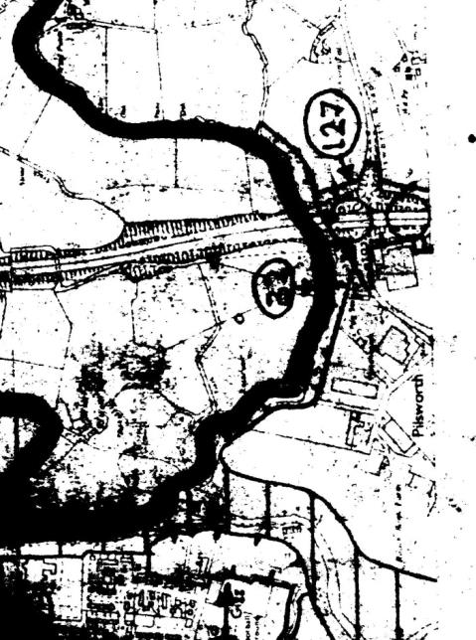
North map of Northern Gateway
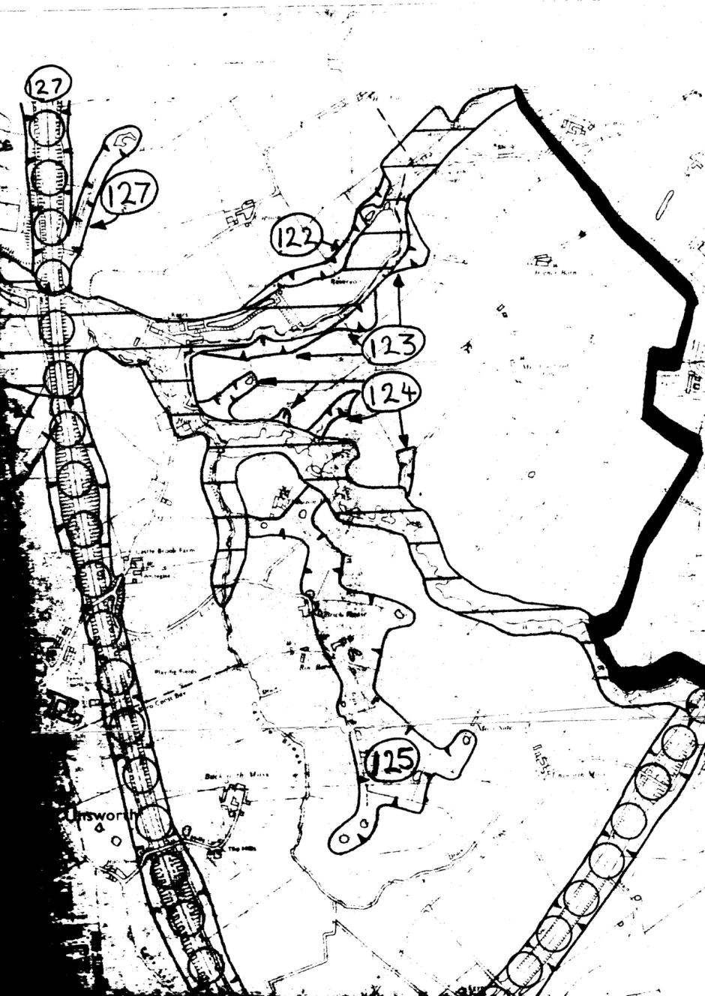

Proposed Wildlife Corridors and Links – middle map of Northern Gateway

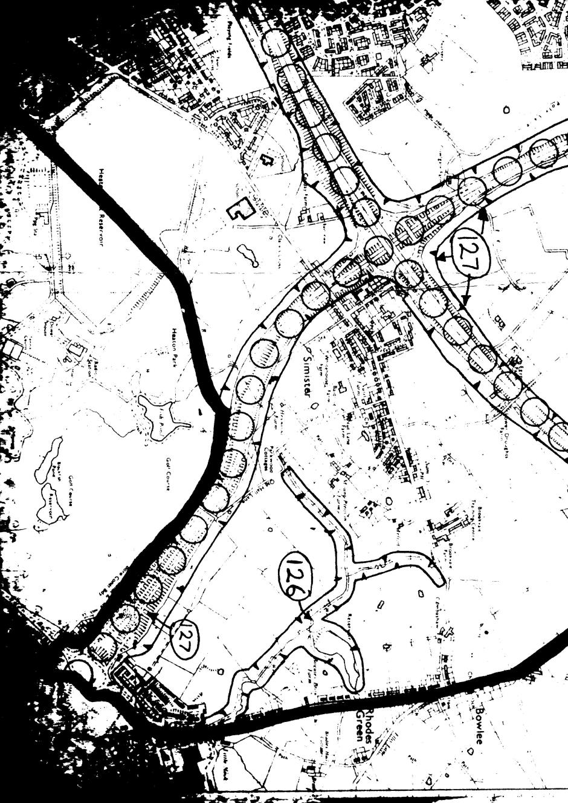
Proposed Wildlife Corridors and Links - south map of Northern Gateway

David Bentley END

