Holcombe Brook Housing Allocation – Greenbelt removal – OBJECTION (Version 5) Page 1/4
David P Bentley Ecological Consultant www.davebentleyecology.co.uk
Representing – nature conservation and landscape
1 This site was Greenbelt from the earliest draft of the Greater Manchester Greenbelt Subject Plan in 1981 (discarded maps I hold at home as I worked at GMC in the Open Land Group at that time).
2 In the Unitary Development Plan (UDP) it is Greenbelt, and the eastern half is Protected River Valley as well. It formed part of the Croal Irwell Valley Subject Plan of Greater Manchester. It is used for grazing horses.
3 Across Hazel Hall Lane is the UDP’s Special Landscape Area of the Irwell Valley. As such ANY development on this site should protect the Special Landscape Area and be screened from it. That said careless planners at Bury MBC have allowed an eyesore, the relocated Tennis Club, to be built on this site which impacts on the Special Landscape Area immensely.
4 The only way to landscape the tennis club part of this site from the Special Landscape Area would be to purchase land on the south east side of the Lane and plant it with native trees. Thus the ALLOCATION SHOULD BE EXTENDED AROUND THE EAST SIDE OF THE TENNIS CLUB to incorporate a buffer strip. No development should be allowed on this housing allocation site until the land is purchased and a planted buffer created. The housing will have to pay for the shielding of the tennis courts.
5 The site contains Features of Ecological Value which should be protected by UDP Policy EN6/2. These features comprise a pond and a stream and semi-improved grassland with Bramble patches. Ponds act as stepping stones for wildlife movement whilst the stream acts as a wildlife corridor despite this not being designated as such by the UDP. The UDP wildlife corridor was drawn by someone retired from the Greater Manchester Ecology Unit who was unfit to draw it - a dinosaur from an age when there was no wildlife protection. When protecting legally protected species to him was drawing a line with a boot on the soil, and then allowing the developers to move it in their favour. Thus the stream (in its entirety) and the pond SHOULD BE INCORPORATED INTO THE WILDLIFE CORRIDOR NETWORK.
6 The wetland and hedgerows and Bramble areas attract insects and feeding Bats. Bats and their habitat must be conserved in this allocation. They are legally protected by UK and EU law. The South Lancashire Bat Group has records of 8 species of Bat being located within 1km of the centre of this site. These are Daubentons, Common Pipistrelle, Soprano Pipistrelle, Brown Long-eared and Noctule, and the much less frequently found Natterers Bat, Brandts Bat and Whiskered Bat. The Noctule, the Brown Long-eared and the Soprano Pipistrelle are UK Biodiversity Action Plan Priority Species, i.e. “Species of principal importance for the purpose of conserving biodiversity” covered under section 41 (England) of the NERC Act (2006) and thus they need to be “taken into consideration by a public body when performing any of its functions with a view to conserving biodiversity.” For Noctules, which had a 21% decline over 6 years prior to UKBAP listing, the JNCC website shows a requirement to protect mature trees, wetlands, stream sides and other insect rich and boosting water quality – developing alongside the brook on this site will not help water quality.
Page 2/4
For Brown Long-eareds, which had a 20% decline over 7 years prior to UKBAP listing, the JNCC website shows a need to protect countryside buildings with roost potential as well as a landscape of woodland edges, hedgerows, small farm woodlands, deciduous and mixed woodland, and connectivity between these. The advice specifically says this: “Ensure the retention and protection of older trees for roosts is included in land-use policies (there are some mature trees here).” For Soprano Pipistrelles, which had a 42% decline prior to UKBAP listing, the JNCC website requires that the needs of the Soprano Pipistrelle are considered in agri-environment, planning, water quality, wetland creation …..policies. The JNCC urges the creation, expansion and improvement of key habitats including wetland and features such as hedgerows and woodland edges. “Ensure adequate consideration of a landscape approach to the conservation of Soprano Pipistrelle.” Alas the housing allocation does quite the opposite.
7 The hedgerows and Bramble patch contain bird nesting and feeding habitats (berries and insects). Nesting habitats are legally protected. This adds to the need to protect these areas.
8 Ponds 7 and 9 of the Bury GCN Survey 2005-6 both support Toads. These ponds are 58m and 198m from the allocation’s south east boundary. The Common Toad is listed by the UK Government as a United Kingdom Biodiversity Action Plan Priority Species, given “serious declines.” This is now
succeeded by the UK Post- 2010 Biodiversity Framework (or “Biodiversity 2020”) and Priority Species are termed Section 41 species, the “revised delivery method” for Common Toad conservation cited as “planning policies and control” (Gov.uk website). JNCC species Priority Species account also states “WIDER ACTION- PLANNING: This amphibian would benefit from recognition of its habitat and management needs at the wider landscape scale both aquatic and terrestrial. Taking account of/ or determining its presence during the early stages of local authority development plans, land allocation (particularly `brownfield sites`) and then development schemes.” Any deficiencies in the planning conditions for the Tennis Club in respect of Toads should be made good via this development. I have been reliably informed that Toads have long been located in the rear gardens of Fernview Drive, and Hazel Hall Lane red brick houses, including this year (photos).

9 The pond was found by me on behalf of Bury MBC in 2005-6 to support Palmate Newts. Photographs of Frogs and Smooth Newts in the rear gardens have been supplied to me (I surveyed it in June when the pond had lost water). The pond receives seepages from under the existing housing so this water will not go away, and water moves to the stream. I have been sent a photo recently showing it currently full of water December 2016. It is a functioning pond and a Feature of Ecological Value. Any proposal should include the enhancement of this pond under direct ecology supervision…not left to a digger driver instructed by his foreman.
10 The stream must stay in an open corridor of semi-improved grassland, which can be left to go rank. Neither the pond nor steam should be included in garden nor sold off to householders in plots. The stream side must not be heavily planted with shrubs.
11 The boundary of this green finger should be bordered by new mixed hedges (no Blackthorn as this suckers).

Page 3/4
12 The link to the Kirklees Valley should be improved if possible and should not be closed by housing or gardens or new roads.
13 The hedgerow on Longsight Road should not be removed. It should be enhanced with native plantings. It may only be breached from an access road at the north end. It should not be included in gardens nor sold to householders.
14 The southern boundary is the boundary to the Special Landscape Area and the development should be screened from the SLA. This can be done by mounding screens and planting of native shrubs. If the boundary needs to be extended to the south side of Hazel Hall Lane then do that. The existing hedge should still be enhanced and should not be incorporated into gardens or sold to householders.
15 The hedgerow in the centre of the site is more problematic. It should be retained as far as possible.
16 The enhancement of the stream and pond strip should include the creation of brick/soil/void/terram and turf amphibian shelter sites. These should be built by ecologists. Bury MBC allowed terrible hibernacula to be provided by the developer of Radcliffe Riding School where a
tower of stone setts and corrugated asbestos was supplied…..and then carted away to the tip when Bury MBC acquired the land.

17 The development should provide a sum to ensure an annual rubbish clearance takes place in the habitat strip and hedges. Bury MBC currently do nothing when people throw bags of rubbish in retained habitats, including those owned by the Council. This should include a sum for habitat maintenance.
18 There should be NO VERTICAL KERBS on the housing development and no gullypots or strip drains into which amphibians might fall. This saves amphibian lives.
19 The site supports Hedgehogs – which is listed by the UK Government as a United Kingdom Biodiversity Action Plan Priority Species, given a 20% decline recorded over 4 years prior to listing as a UKBAP species. This is now succeeded by the UK Post-2010 Biodiversity Framework (or “Biodiversity 2020”) and Priority Species are termed Section 41 species. Species “of principal importance for the purpose of conserving biodiversity” covered under section 41 (England) of the NERC Act (2006) and therefore need to be taken into consideration by a public body when performing any of its functions with a view to conserving biodiversity. Concerns cited are traffic density, fragmentation of habitats, need for hibernation sites, need for hedgerows and wide field margins.
20 The EU Water Framework Directive requires environmental objectives be set for all surface and ground waters to enable them to achieve good status or potential for heavily modified water bodies by a defined date. One objective is to prevent further deterioration which can include changes to flow pattern, width and depth of channel, sediment availability/transport and ecology and biology.
Page 4/4
21 Finally, we have seen several examples in Bury where a site is allocated with a Features of Ecological Value note attached to the allocation. The owner then goes about trashing the wildlife in that note. We have seen wildlife trashed in advance of development at Edgar’s Field, Spen Moor, Openshaw Fold and Townside Fields in recent times. Thus to avoid this happening the area to be protected should be removed from the allocation now and have its Greenbelt status retained, a green finger. The finger should be staked out by Bury Council and the locations verified and photographed. This is because Bury Planning has a history of agreeing boundaries to retained nature areas and then allowing the developers to place garden fences inside that area. The retained land, if it belongs to Bury MBC, should be retained in Council ownership. It should not be let nor allowed to be occupied by squatters, something Bury MBC does allow through the incompetence and wilful negligence of its staff.
Dave Bentley (Photos supplied by residents of Hazel Hall Area)
Photos follow
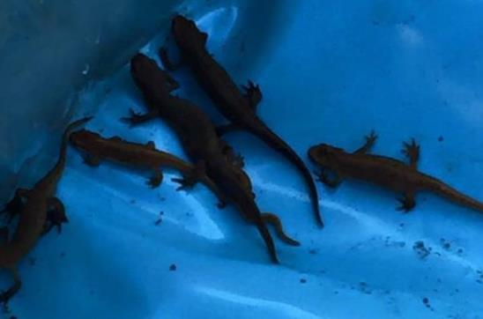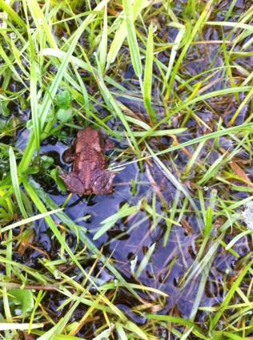
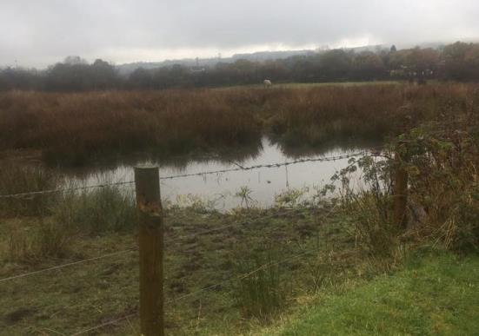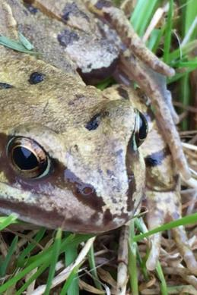 END

